Social

Psychology



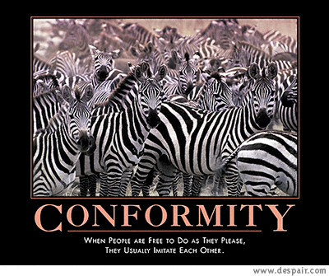

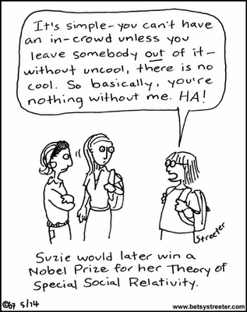

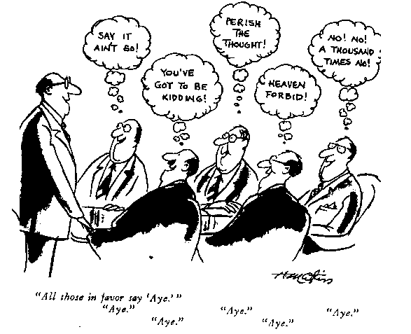

**Terms for Flashcards Unit 11:**

***Social Psychology***

|  |  |  |
| --- | --- | --- |
| Attribution theory | Group polarization | Frustration-aggression principle |
| Fundamental attribution error | Groupthink | Social script |
| Attitude | Norm | Mere exposure effect |
| Foot-in-the-door phenomenon | Prejudice | Altruism |
| Role | Stereotype | Bystander effect |
| Cognitive dissonance theory | Discrimination | Social exchange theory |
| Conformity | Just-world phenomenon | Conflict |
| Normative social influence | Ingroup bias | Social trap |
| Informational social influence | Outgroup bias | Self-fulfilling prophecy |
| Social facilitation | Scapegoat theory | Superordinate goals |
| Social loafing | Other-race effect | Door-in-the-face phenomenon |
| Deindividuation | aggression |  |

Pick 15 terms from the above list that you are least familiar/comfortable with and construct a flash card including the following information:

1. **Define** the term IN YOUR OWN WORDS. Try and keep the definition short, meaningful, and something that you can remember.
2. **Draw** a picture that demonstrates the term OR describe a personal example.



**But My Teacher Made Me Do It**

**Purpose:**

* To study the effects of abnormal behavior on others.
* To experience the effects of being considered abnormal by others.

**What to do:**

* Think of an abnormal behavior that you can perform "in Public" (this could include doing something with your friends without notice).
* Do something crazy. For example, one student walked through a shopping mall near her home holding an open umbrella above her head.
* Do not do anything that would cause others harm in any way or that would obstruct traffic or peoples' usual activities or commerce.
* Write a two paragraph report including:
  + Describe what social norm you broke and how.
  + Describe people’s reactions.

Report is due: \_\_\_\_\_\_\_\_\_\_\_\_\_\_\_\_\_\_\_\_\_\_\_\_\_\_\_\_\_

No Lates. No Exceptions.

**Random Act of Kindness**

**Purpose:**

AMHAPPY

* To study the impact of doing something nice without

expectations

* To experience the effect of helping others

**What to do:**

* Think of something you could do to help or create a

positive experience for someone you do not already

know.

* Plan the event and complete your random act outside of school.
* Write a two paragraph report including:
  + Describe what random act you performed.
  + Describe the person’s reaction.
  + Reflect on whether or not you enjoyed this deed and explain your answer.

Report is due:\_\_\_\_\_\_\_\_\_\_

No Lates. No Exceptions.

Name\_\_\_\_\_\_\_\_\_\_\_\_\_\_\_\_\_\_\_\_\_\_\_\_\_\_\_\_\_\_\_\_\_\_\_\_\_\_\_\_\_\_\_\_

Prisoner’s Dilemma

Go to the following website: http://serendip.brynmawr.edu/playground/pd.html

Read the directions carefully, create a strategy, and then begin playing the game. When you finish the game, answer the following questions.

1. What was your strategy before you began playing?

2. Did your strategy change as you played the game? How? Why? If not, why not?

3. Did your strategy work? How many gold coins did you have at the end of the game (record your first game only)? How many gold coins did Serendip have? Record your average and Serendip’s average for all of the games you played.

4. Relate this game to the Prisoner’s Dilemma.

5. What were the difficulties or frustrations you encountered while playing the game?

***C:\Documents and Settings\heather_weisenburger\Local Settings\Temporary Internet Files\Content.IE5\K552KPA8\MC900391034[1].wmfStanford Prison Experiment Lab Activity***

Follow the directions below, read about one of the most famous/infamous Social Psychology experiments and answer the discussion questions.

1. Go to <http://www.prisonexp.org/>
2. Click on “Take the Slide Show” on the upper right of the page
3. Read through the 42 slides. The experiment will be described to you in detail with corresponding pictures from the actual experiment. Some slides will have questions, after reading the preceding information, answer each discussion question in the space below. You can tell which slide you are on by looking at the address bar at the top of the browser.

***Discussion Questions***

**Slide 6**- What are the effects of living in an environment with no clocks, no view of the outside world, and minimal sensory stimulation?

**Slide 9**- Consider the psychological consequences of stripping, delousing, and shaving the heads of prisoners or members of the military. What transformations take place when people go through an experience like this?

**Slide 15**- At first push-ups were not a very aversive form of punishment, but they became more so as the study wore on. Why the change?

**Slide 19**-How do you think you would have behaved if you were a prisoner in this situation? Would you have rejected these privileges in order to maintain prisoner solidarity?

**Slide 24**- Compare the reactions of these visitors to the reactions of civilians in encounters with the police or other authorities. How typical was their behavior?

**Slide 27**-In an exploratory study such as this, one problem is defining what the "data" are -- the information we should collect. Also, what should have been done to minimize the effects of experimenter bias on the outcome of the study? What were the dangers of the principal investigator assuming the role of prison superintendent?

**Slide 33**-In 2003 U.S. soldiers abused Iraqi prisoners held at Abu Ghraib, 20 miles west of Baghdad. The prisoners were stripped, made to wear bags over their heads, and sexually humiliated while the guards laughed and took photographs. How is this abuse similar to or different from what took place in the Stanford Prison Experiment?

**Slide 39**-In the encounter sessions, all the prisoners were happy the experiment was over, but most of the guards were upset that the study was terminated prematurely. Why do you think the guards reacted this way?

C:\Documents and Settings\heather_weisenburger\Local Settings\Temporary Internet Files\Content.IE5\QG31UW80\MC900312298[1].wmf

Name\_\_\_\_\_\_\_\_\_\_\_\_\_\_\_\_\_\_\_\_\_\_\_\_\_\_\_\_\_\_\_\_\_\_\_\_\_\_\_\_

A CLASS DIVIDED VIDEO QUESTIONS

1. What did the children's body language indicate about the impact of discrimination?
2. How did the negative and positive labels placed on a group become self-fulfilling prophecies?
3. Both Elliott and her former students talk about whether or not this exercise should be done with all children. What do you think? If the exercise could be harmful to children, as Elliott suggests, what do you think actual discrimination might do?

Name:\_\_\_\_\_\_\_\_\_\_\_\_\_\_\_\_\_\_\_\_\_\_\_\_\_\_\_\_\_\_\_\_

**MEAN GIRLS & SOCIAL PSYCHOLOGY**

|  |  |  |
| --- | --- | --- |
| **TERM** | **EXAMPLE #1** | **EXAMPLE #2** |
| ATTRIBUTIONS  Theory that we tend to give  casual explanation for someone’s behavior, by crediting the person’s disposition, (**dispositional attribution**) **or** the situation, (**situational attribution**). |  |  |
| ATTITUDES  belief and feeling that predisposes one to respond in a particular way to objects, people and events. |  |  |
| INGROUP BIAS  “Us”- people with whom one shares a common identity vs. minority |  |  |
| OBEDIENCE  **Compliance** with a demand |  |  |